**DIGITAL SIGNAGE**



Project Id: **BIT-2109**

Session: **2021-2025**

Submitted By:

**Aleeza Aftab (BIT21208)**

**Ayesha Shahbaz (BIT21242)**

**STATEMENT OF SUBMISSION**

This is to certify that following students have successfully completed the final project named as: Digital Signage at University of the Punjab, Gujranwala Campus, Gujranwala, to fulfill the partial requirement of the degree of **bachelor’s in information technology.**

|  |  |  |
| --- | --- | --- |
| **Sr. No.** | **Student’s Roll No.** | **Student’s Name** |
| 1 | BIT21208 | Aleeza Aftab |
| 2 | BIT21242 | Ayesha Shahbaz |

______________________ __________________

**Internal Supervisor**   **External Supervisor**

Dr Salmaan Naseer AdilName of External Supervisor

**______________________ __________________**

**Project Coordinator Incharge IT-Department**

Prof. Muhammad Younas Dr. Naveed Ahmed Jhammat

PUGC. PUGC.

**___________________**

**Director General**

Prof. Dr. Muhammad Mudasar Ghafoor

PUGC.

**PROOFREADING CERTIFICATE**

It is to certify that I have read the document thoroughly and circumspectly. I am convinced that the resultant project does not contain any spelling, punctuation or grammatical mistakes as such. All in all, I find this document well organized, and I am in no doubt that its objectives have been successfully met.

***_____________________***

Teacher Name

Designation,

Name of Institute

Acknowledgements

We are grateful to The University of Punjab for giving us a wonderful platform for exploring our Information Technology skills during making the project. Also, thanks for providing us with the best and most qualified teaching staff. This project is the direct result of teamwork. We sincerely thank the instructors and students who have shared their suggestions with us over the last few weeks.

Many thanks go **to Prof. Muhammad Younas** and **Prof. Dr. Salman Naseer Adil** our Project coordinator and supervisor, whose management helped us to get this project produced in timely and efficient manner.

And finally, we thank **Prof. Moodsar Hussain** who weren’t directly involved in this project but who stood by us the whole way, we appreciate your encouragement and support. We are also thankful to our friends and families whose silent support led us to complete our project.

***Write to us***

We welcome your response to this poject. If there is anything you want to mention about the improvement of this project, please let us know:

Aleeza Aftab [aleezaaftab338@gmail.com](mailto:aleezaaftab338@gmail.com)

Ayesha Shahbaz choudharyayesha644@gmail.com

**ABSTRACT**

In rapid development of information technology, E-Commerce is going to be very common. To achieve competitive advantage in the market it is necessary to move towards E-Commerce. Digital signage System is a web-based application that enables the Customer to see all the details of the product including features and price. In absence of a salesman, customers can explore products by themselves instead of waiting. To reduce display costs and other costs. Owners can maintain inventory records. Customers can see the availability and unavailability of products. The system is hence useful for both customers and manager. All this is packaged in this wonderfully developed, passion oriented project which is fruit of our endless efforts

***For Our Beloved Parents and Teachers***

*“Dedicated to our parents and teachers without whose wholehearted support, encouragement and guidance it would have been impossible for us to make this project.”*

**Table of contents:**

**`1 Chapter 1: Project Feasibility Report……………………………………………...10**

1.1 Product/Project Feasibility Report…………………………………………….11

1.1.1 Technical Feasibility 11

1.1.2 Operational Feasibility……………………………………………………11

1.1.3 Economic Feasibility 12

1.1.4 Schedule Feasibility 12

1.1.5 Specification Feasibility 12

1.1.6 Information Feasibility 12

1.1.7 Motivational Feasibility 12

1.1.8 Legal & Ethical Feasibility 13

1.2 Project/Product Scope…………………………………………………………...13

**2 Chapter 2: Project Costing………………………………………………….…..14**

2.1 Project/Product Costing…………………………………………………………15

2.1.1 Project Cost Estimation by Function Point Analysis 15

2.1.2 Calculation of (Fi) 17

2.1.3 Calculation of functional Point(FP)……………………………………….18

2.1.4 Total Cost of the Project…………………………………………………..18

**3 Chapter 3: Critical path Method………………………………………………19**

3.1 CPM - Critical Path Method …………………………...……………………….20

3.1.1 Specify the Individual Activities 20

3.1.2 Determine the Sequence of the Activities 20

3.1.3 Network Diagram 21

3.1.4 Estimate Activity Completion Time 21

3.1.5 Identify the Critical Path 21

4 Chapter 4: Planning Project 23

4.1 Gantt Chart 23

4.2 Introduction to Team Members and their skill set 23

4.3 Tools and Technology with reasoning………………………………………...…25

4.4 Vision Document…………………………………………………………….......27

4.5 Risk List 27

5 Chapter 5: System Requirement Specification 29

5.1 Requirement Engineering………………………………………………………...30

5.1.1 Systems Specifications 31

5.2 Organizational Chart……………………………………………………………..32

5.3 Scope of the System……………………………………………………………...32

5.4 Summary of Requirements (Initial Requirements)………………………………33

5.5 Identifying External Entities……………………………………………………..33

5.6 Context Level Data Flow Diagram………………………………………………35

5.7 Capture“Shall Statement”………………………………………………………...35

5.8 "Allocate Requirements”………………………………………………………...36

5.9 "Prioritize Requirement”…………………………………………………………37

5.10 “Requirement Trace-ability Matrix”……………………………………………..39

5.11 High Level Use Case Diagram…………………………………………………..39

6 Chapter 6: Use Case Diagram 41

6.1 Use Case Diagram Description…….. ……………………………………………42

7 Chapter7: Domain Model 48

7.1 Domain Model…………………………………………………………………...49

8 Chapter8: Sequence Diagram 50

8.1 Sequence Diagrams:……………………………………………………………...50

2.6.1. SD 1: Login 51

2.6.2. SD 2: Manage Products 51

2.6.3. SD 3: Manage Customers……………………………………………… ……52

2.6.4. SD 4: Place Order……………………………………………………………52

2.6.5 SD 5: Make Payment…………………………………………………………53

2.6.6 SD 6: Feedback……………………………………………………………….53

2.6.7 SD 7: Logout………………………………………………………………….54

**9 Chapter 09: Collaboration Diagram…………………………………………….55**

9.1 Collaboration Diagram………………………………………………………….56

**10 Chapter 10**: **Operation Contract……………………………………………....….61**

10.1 Operation Contract……………………………………………………………...62

10.6.1 Contract co1: 62

UC_ Registration: 62

10.6.2 Contract co2: 62

UC_ Login: 62

10.6.3 Contract co3: 62

UC_ Manage Product_info: 62

10.6.4 Contract co4: 63

UC_ Manage Order: 63

10.6.5 Contract co5: 63

UC_ Manage Reports: 63

10.6.6 Contract co6: 63

UC_ Payment Handling: 63

11 Chapter 11: Class Diagram 65

11.1 Class Diagram:…………………………………………………………………..66

12 Chapter 12:Data Model 67

12.1 Data Model:……………………………………………………………………..68



Chapter 01

Feasibility Report

* 1. ***Project/Product Feasibility Report***

We have carried out the following feasibilities for our project.

* Technical
* Operational
* Economic
* Schedule
* Specification
* Information’
* Motivational
* Legal and Ethical
* Risk list

### 1.1.1 Technical Feasibility

The proposed system will be developed in app bases completely and it is required to use app technologies appropriately. Technology to build the overall system is available. Currently available app technologies

* **App Tools:**

Visual Studio

XAMPP server

* **Database**

MySQL

The system is developed using C#, ASP>Net, JavaScript, Html, CSS and Bootstrap. Core as the main development language. We are assured that our software team currently possesses the required expertise to complete the system and it is clearly defined that the project is successfully and professionally in our grip.

**1.1.2 Operational Feasibility**

Potential users of the Digital Signage app are already acquainted with digital interfaces, making the training process straightforward. The implementation of the Digital Signage app within existing networks can be seamlessly managed. Addressing security concerns will be a priority, either at the network level or within the application itself, ensuring secure and reliable deployment. The Digital Signage app is designed to streamline data entry processes, reducing the need for manual labor. With automated content management, fewer personnel will be required for data entry and information processing, leading to cost savings. Personal information, stock details, and other relevant data are efficiently managed within the app's database. The Digital Signage app is tailored to enhance user convenience, streamline operations, and optimize the overall digital signage experience for both users and customers.

### 1.1.3 Economic Feasibility

Assessing the economic feasibility of a digital signage project is pivotal, demanding a detailed examination of upfront and continuous expenses. Utilizing an economic feasibility report, we've conducted a comprehensive cost/benefit analysis for the project, distinctly categorized into cost estimates and benefit estimates. Employing Functional Point Analysis (FPA) as a prominent cost estimation model, we've briefly scrutinized the development or acquisition costs (one-time) and the ongoing maintenance and operation costs. Development costs, calculated by segmenting the project, amount to approximately Rs. 95,000. In the realm of benefit estimation, we distinguish between substantial and insubstantial benefits. Leveraging substantial benefits not only mitigates costs but also augments revenue, enhancing the overall economic viability of the project.

### 1.1.4 Schedule Feasibility

We've confidently evaluated the schedule feasibility, ensuring successful project completion within the allocated timeframe and available resources. Meticulous scheduling, utilizing a Gantt chart and Critical Path Methodology, includes calculating essential time limits and milestones. With our strategic approach, we are poised to meet all deadlines, ensuring a seamless and punctual digital signage project development process without delays or time slippage.

### 1.1.5 Specification Feasibility

In terms of Specification Feasibility, we have confidence that our project will fulfill all essential specifications. Our team members have a clear understanding of all defined requirements, and both hardware and software specifications align well with the project's completion. The boundaries of the project scope have been thoroughly assessed and are well-defined.

### 1.1.6 Information Feasibility

In the information feasibility analysis, we thoroughly examined the adequacy, consistency, and relevance of available information for the project. Conclusively, we determined that the gathered information is sufficient and meets the requirements for application development.

### 1.1.7 Motivational Feasibility

A successful project captivates viewers, inspires valuable lessons, and fosters team enthusiasm for enhanced learning and achieving project objectives. Team members are motivated by the prospect of accessing additional conveniences, fueling their commitment to project development.

### 1.1.8 Legal & Ethical Feasibility

The completion of the project is free from any legal or moral concerns, ensuring its absolute legality and non-disruptive nature. It will not pose any issues for others, maintaining a lawful and ethical framework.

## *Project/Product Scope*

**“Digital Signage”** is an online utility for the people; it has all the major features which are essential for a full-fledged application. Now user can see the details of the product on the Digital Screen and order the products by using it. It also reduces the number of salesmen. Users can buy, can check the specifications of product, can pay online payment as well as users can change or cancel the product within

the time constraints. Digital Signage System will do the following tasks:

* Digital Signage System *aims to maintain and manage the various tasks and processes.*
* *It’ll give information about the products and their price (and discount if given) current availability status.*
* The system will allow users to register their account and purchase the products.
* The design of the application will involve videos and pictures and search the product and its details like price and discount.
* The selected product can be added into the cart
* It will provide information about products.
* Customers can view, order and online payment of it.



Chapter 02

**Project Cost**

## *2.1 Project/Product Costing*

Determining the cost of a project is an important step in project management, and various techniques are employed for this purpose. Determining the cost of a project is a crucial step in project management, and various techniques are employed for this purpose like COCOMO and FP (functional point) Analysis. We will follow FP Analysis for this purpose.

### 2.1.1 Project Cost Estimation by Function Point Analysis

|  |  |  |  |
| --- | --- | --- | --- |
| **Internal Logical File (ILF’s)** | | | |
| **Type of Components** | **DET** | **RET** | **Complexity** |
| Admin_Credentials | 3 | 0 | Low |
| User_Credentials | 14 | 0 | Low |
| User Quires | 7 | 0 | Low |
| Products | 10 | 0 | Low |
| Product Details | 3 | 2 | Low |
| Product Features | 3 | 2 | Low |
| Add to cart Details | 9 | 1 | Low |
| Order Details | 15 | 2 | Low |
| Contact Detail | 10 | 0 | Low |
| Carousel | 2 | 0 | Low |
| Facilities | 4 | 0 | Low |
| Features | 2 | 0 | Low |
| Setting | 4 | 0 | Low |

|  |  |  |  |
| --- | --- | --- | --- |
| **External Inputs (EI’s)** | | | |
| **Types of Components** | **DET** | **FTR** | **Complexity** |
| Login | 2 |  | Low |
| Logout | 1 | 1 | Low |
| Registration | 6 | 1 | Low |
| Product Detail | 2 | 1 | Low |
| Order Detail | 2 | 1 | Low |
| Order Status | 2 | 1 | Low |
| Review | 8 | 3 | Low |
| Payment Method | 3 | 1 | Low |
| Payment Status | 2 | 1 | Low |

|  |  |  |  |
| --- | --- | --- | --- |
| **External Interface File (EIF’s)** | | | |
| **Types of Components** | **DET** | **RET** | **Complexity** |
| PayPal | 3 | 1 | Low |
| Email Confirmation | 2 | 1 | Low |

|  |  |  |  |
| --- | --- | --- | --- |
| **External Output (EO’s)** | | | |
| **Types of Components** | **DET** | **FTR** | **Complexity** |
| Email Confirmation | 2 | 2 | Low |
| Daily Reports | 2 | 2 | Low |
| Weekly Reports | 2 | 2 | Low |
| Monthly Reports | 2 | 2 | Low |

|  |  |  |  |
| --- | --- | --- | --- |
| **External Queries (EQ’s)** | | | |
| **Types of Components** | **DET** | **FTR** | **Complexity** |
| List of Products | 5 | 2 | Low |
| List of In stock Products | 7 | 2 | Low |
| List of sold products | 7 | 2 | Low |
| List of Customers | 7 | 1 | Low |

Computing Function Points:

|  |  |  |  |  |
| --- | --- | --- | --- | --- |
| **Type of Component** | **Complexity of Components** | | | |
|  | **Low** | **Average** | **High** | **Total** |
| **External Inputs** | 9 x 3 = 27 | 0 x 4 = 0 | 0 x 6 = 0 | 27 |
| **External Outputs** | 4 x 4 =16 | 0 x 5 = 0 | 0 x 7 = 0 | 16 |
| **External Queries** | 4 x 3= 12 | 0 x 4 = 0 | 0 x 6 = 0 | 12 |
| **Internal Logical Files** | 5 x 7= 35 | 0 x 10 = 0 | 0 x 15 = 0 | 35 |
| **External Interface Files** | 2 x 5 =10 | 0 x 7 = 0 | 0 x 10 = 0 | 10 |
| **Total Unadjusted Function Points (UFPs)** | | | | 100 |

### 2.1.2 Calculation of (Fi)

|  |  |
| --- | --- |
| **GSC** | **Value (0-5)** |
| Data communications | 4 |
| Distributed data processing | 0 |
| Performance | 5 |
| Heavily used configuration | 0 |
| Transaction rate | 0 |
| On-Line data entry | 3 |
| End-user efficiency | 1 |
| On-Line update | 4 |
| Complex processing | 4 |
| Reusability | 3 |
| Installation ease | 0 |
| Operational ease | 5 |
| Multiple sites | 0 |
| Facilitate change | 4 |
| **Total** | **33** |

**2.1.3 Calculation of Function Point (FP)**

To compute function points (FP), the following relationship is used:

**VAF** = (0.01 x TDI) + 0.65

= (0.01 x 33) + 0.65

= 0.98

**AFP count** = UFP count x VAF

= 100 x 0.98

= 98 FP

**2.1.4 Total Cost of the Project**

Suppose cost to solve one FP = Rs. 600

|  |  |
| --- | --- |
| **Total Cost** | = Cost Per FP * Total FP |
|  | = 600 * 98 |
|  | **= 58,800PKR** |

Finally, Total Project Cost and Total Project Effort are calculated given the average productivity parameter for the system.



Chapter 03

**Critical Path Method**

***3.1 CPM - Critical Path Method***

**3.1.1 Specify the Individual Activities**

Following are the individual activities involved in the project.

❖ Project Proposal

❖ Project Planning

❖ Requirement Gathering

❖ Design, Layout

❖ Development

❖ Modules

❖ Backend

❖ Database Connectivity

❖ Integration

❖ Testing

**3.1.2. Determine the Sequence of the Activities**

There are many activities that are dependent on the completion of some other activities.

The dependencies of activities upon each other are as under.

|  |  |  |
| --- | --- | --- |
| **ID** | **Activity** | **Dependencies** |
| A | Requirement Gathering | None |
| B | Design, Layout, and structure | A |
| C | Development and Modules | A, B |
| D | Backend | C |
| E | Database Connectivity | D |
| F | Integration | E |
| G | Testing | F |



**3.1.4 Estimate Activity Completion Time**

The time required to complete each activity can be estimated using experience or the estimates of knowledge persons.

|  |  |  |
| --- | --- | --- |
| **ID** | **Predecessors** | **Duration (days)** |
| A | None | 14 days |
| B | A | 21 days |
| C | A, B | 28 days |
| D | C | 28 days |
| E | B, D | 7 days |
| F | B, C, D, E | 14 days |
| G | F | 21 days |

**3.1.5 Identify the Critical Path**

|  |  |  |  |  |  |  |  |
| --- | --- | --- | --- | --- | --- | --- | --- |
| **Activity** | **Duration** | **ES** | **EF** | **LS** | **LF** | **TS** | **FS** |
| A | 14 | 0 | 14 | 0 | 14 | 0 | 0 |
| B | 21 | 14 | 35 | 14 | 35 | 0 | 0 |
| C | 28 | 35 | 63 | 35 | 63 | 0 | 0 |
| D | 28 | 63 | 91 | 63 | 91 | 0 | 0 |
| E | 7 | 91 | 98 | 91 | 98 | 0 | 0 |
| F | 14 | 98 | 112 | 98 | 112 | 0 | 0 |
| G | 21 | 112 | 133 | 112 | 133 | 0 | 0 |

**Critical path is** A ->B ->C ->D ->E ->F ->G =133

Chapter 04

Project Planning

## *4.1 Gantt chart*

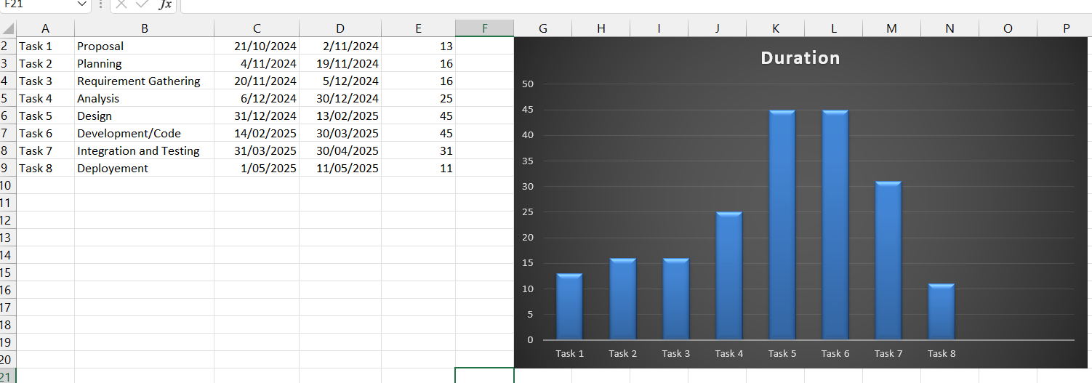

## *4.2 Introduction to Team members and their skill set.*

|  |  |  |
| --- | --- | --- |
| **Name** | **Roll no** | **Email Address** |
| Aleeza Aftab | BIT21208 | aleezaftab338@gmail.com |
| Ayesha Shahbaz | BIT21242 | Choudharyayesha644@gmail.com |

**Skills:**

**Aleeza Aftab:**

She is responsible for managing Database activities and she has maximum potential to document the things in standardized format

**Ayesha Shahbaz:**

She is responsible for utilizing their expertise in marketing and branding to strategize the

content and messaging on the digital signage app. and maintaining the digital signage app.

## *4.3 Tools and Technology with reasoning*

* **Technology and Languages:**

**C#**

C# is a popular programming language. It offers a lot of flexibility and power. It is widely used for building windows applications, web applications and even games so, we are going to develop an app, this language is used in development.

**ASP.NET**

ASP.NET is a server-side scripting technology that allows you to use a full featured

programming language such as C# etc. to build applications easily.

**JavaScript**

JavaScript works on the Client Side. It manipulates the objects within the HTML document. JavaScript is a scripting language that enables you to create dynamically update content, control multimedia, animate images, and pretty much everything else.

**Java**

Java is used for app development because of its versatility and platform independence. It allows developers to wide code once and run it on multiple platforms. It also has a large ecosystem of libraries and frameworks that simplify app development.

**Html**

HMTL is used to create webpage layouts. HTML5 is a standard for structuring and presenting content on the World Wide Web. JavaScript and jQuery enhance the functionality of Webpages by making them interactive. These are lightweight client-side scripting languages.

**CSS**

CSS is a language that describes the style of an HTML document.CSS describes how HTML elements should be displayed. It is a language used to detail the presentation of a web page's markup language (most commonly HTML or XHTML) – such as colors, fonts, and layout. One of its key benefits is the way it allows the separation of document content (written in HTML or a similar markup language) from document presentation (written in CSS).

**Bootstrap**

Bootstrap includes several components and options for laying out your project, including wrapping containers, a powerful flex- box-grid system, a flexible media object, and responsive utility classes.

* **Application Tools:**

**Visual Studio**

Visual Studio Code is a free coding editor that helps you start coding quickly. Use it to code in any programming language, without switching editors. Visual Studio Code has support for many languages, including Python, Java, C++, JavaScript, and more.

**Xampp Server**

XAMPP is a free and open-source cross-platform. It combines Apache, MySQL, PHP and perl into a single package, making it easy to install and figure. With Xampp, developers can test their apps locally before deploying them to a live server.

* **Database:**

**MySQL**

MySQL is an **open-source relational database management system**. As with other relational databases, MySQL stores data in tables made up of rows and columns. Users can define, manipulate, control, and query data using Structured Query Language, more commonly known as SQL.

* **Documentation:**

**Microsoft Visio**

Microsoft Visio is a diagramming and vector graphics application and is part of the Microsoft Office family. The product was first introduced in 1992, made by the Shape ware Corporation. It was acquired by Microsoft in 2000.

**Microsoft word**

Microsoft is a graphical word processing program that users can type with. It is made by Microsoft. The purpose of MS Word is to allow the users to type and save documents. Like other word processors, it has helpful tools to make documents. Spelling and Punctuation checking feature in Microsoft word helps us to correct the spellings in our documents. We use Microsoft Word for the documentation of our project.

***4.4 Vision Document***

The Digital Signage App is designed to revolutionize the in-store experience for both businesses and customers. By leveraging dynamic digital screens in shops, this app aims to provide an interactive platform for businesses to showcase products, promotions, and essential information while enhancing the overall shopping experience forcustomers***.***

**Key Features:**

* Foster meaningful interactions between customers and businesses through interactive digital displays.
* Empower businesses to communicate real-time information, promotions, and updates to customers.
* Increase brand visibility and recognition by creating visually appealing and customized digital content.
* Allow businesses to display dynamic content, including images, videos, and text, ensuring an engaging and up-to-date shopping environment.
* Enable businesses to conveniently update and manage displayed content remotely, ensuring flexibility and efficiency.
* Implement touchscreen features on digital screens, providing customers with an interactive experience to explore product details and promotions.
* Leverage the app to promote products, increase brand visibility, and enhance the overall in-store experience.
* Benefit from real-time information, interactive displays, and an engaging shopping experience.

## *4.5 Risk List*

* Poor communication between the development team and client.
* Lack of resources.
* In any case, database connectivity issue.
* Time constraint.
* Any member may leave the group.
* Technology may change during the project.
* Ignorance of non-functional requirements.
* Lack of expertise.
* Unexpected project scope expansions.
* Lack of cooperation from team members.
* Security issues in critical moments.



Chapter 5

**Requirement Engineering**

## 

## *5.1 Introduction*

Requirements engineering process provides the appropriate mechanism for understanding what the customer wants, analyzing need, assessing feasibility, negotiating a reasonable solution, specifying the solution unambiguously, validating the specification and managing the requirements as they are transformed into an operational system. The task of capturing, structuring, and accurately representing the user's requirements so that they can be correctly embodied in systems which meet those requirements (i.e. are of good quality).

* Requirements elicitation
* Requirements analysis and negotiation
* Requirements specification
* System modeling
* Requirements validation
* Requirements management

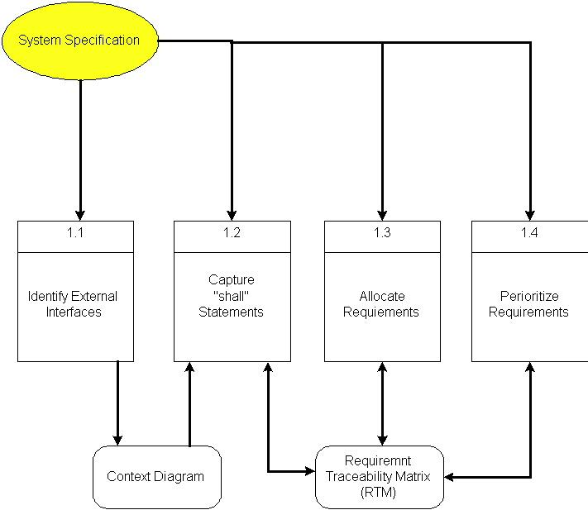

Here, requirements specification is to be discussed. Requirements specification would lead to the following four steps:

* Identify external interfaces
* Development of context diagram
* Capture “shall statements
* Allocate requirements
* Prioritize requirements
* Development of requirements traceability matrix

### 5.1.1 Systems Specifications

**Introduction**

Digital signage is an application for displaying stuff in shops or places. It's a fancy upgrade from the old video signs you used to see in stores. Instead of VHS tapes, it now uses digital files (like on DVDs or USB drives) to show pictures, text, or videos on screens. You connect these files to a player, which puts them on the screen. Unlike before, modern systems allow different content on each screen, enhancing customization. thanks to improvements, you can make each screen show

It's basically a cool way for stores to show off things in a modern and customizable way. Its primary aim is to enhance customer experience by efficiently displaying product information through photos, videos, and features, reducing the need for customers to wait in line to talk to staff. This helps businesses save costs on traditional displays and staff resources while providing valuable information to customers in a strategic manner.

**Existing System**

Before computers took over, showing off products needed lots of money and salespeople. Now, with "Digital Signage," it's cheaper, requires fewer salespeople, and lets you display pictures, videos, and product details. Putting electronic displays in smart places with helpful info lets customers check out products without waiting to talk to staff.

***5.2 Organizational Chart***

Digital Signage





Admin

Customer

Login

Registration

Login

Manage Customer

View Products

Manage Products

Manage Cart Items

Add Items to Cart

Manage Order

Place Order

Make Payment

Manage Payment

Logout

Logout

***5.3 Scope of the System***

The system under development will be dealing with Digital signage in different cities across the country and will:

* Allow customers to effortlessly view all products on display screens by themselves.
* Allow customers to see the availability or unavailability of the product.
* Allow customers to see the detailed information(features, price ,etc.)of the products.
* Allow customers to navigate through customized content on different screens.
* Provide customers with a self-paced and informative experience, eliminating the need to wait in line.
* Allow customers to enjoy visually appealing presentations of products, promotions, and features.
* Allow customers to add items in the cart.
* Allow customers to seamlessly place orders and also track their orders.
* Allow different payment methods for customers.

***5.4 Summary of Requirements (Initial Requirements)***

**1.Centralized Management:**

Implement a central player for seamless connectivity and management of screens.

**2.User interface and Experience:**

Create a initiative user interface that will enable customers to independently view all products displayed on screens.

**3. Real-Time Availability:**

Implement a feature displaying real-time product availability status.

**4. Detailed Product Information:**

Provide customers with comprehensive product details, including features, pricing, etc.

**5. Customized Content Navigation:**

Allow customers to navigate through tailored content on different screens for an enhanced and personalized experience.

**6. Visual Presentation:**

Create visually appealing presentations of products, promotions, and features for an engaging customer experience.

**7. E-commerce Integration:**

Enable customers to add items to their cart within the digital signage system.

**8. Order Placement and Tracking:**

Implement seamless order placement and tracking functionalities for customer convenience.

**9. Payment Flexibility:**

Support various payment methods to accommodate different customer preferences.

### *5.5 Identifying External Entities*

The Identification of External Entities is done in two phases.

**a. Over Specify Entities from Abstract**

On the basis of the Abstract, one might identify the entities from the problem:

* Registration
* Login
* Admin
* Central Player
* Screens
* Customer Experience
* Product Information
* Photos
* Videos
* Features
* Traditional Displays
* Staff Resources
* Strategic Information
* Independent Product Viewing
* Availability Checking
* Detailed Information Access
* Customized Content Navigation
* Visually Appealing Presentations
* Add Items to Cart
* Order Placement and Tracking
* Payment
* Logout

**b. Perform Refinement**

The following entities more related to our business logic;

* Admin
* Screens
* Independent Product Viewing
* Detailed Information Access
* Customized Content Navigation
* Visually Appealing Presentations
* Add Items to Cart
* Order Placement and Tracking
* Payment

### 

### *5.6 Context Level Data Flow Diagram*

Admin Management



Product Management

Customer Management



### 

Order Management

Cart Items Management

### 

### 

Payment Handling

***5.7Capture "shall" Statements***

|  |  |  |
| --- | --- | --- |
| **Para #** | **External Entity** | **Initial Requirements** |
| 1 | System | System “shall” maintain information of all products in database. |
| 2 | System | System “shall” display visual presentation of all products. |
| 3 | System | System “shall” display availability status of all products. |
| 4 | System | System “shall” show detailed information of each product. |
| 5 | Admin | Admin “shall” login to the system. |
| 6 | Admin | Admin “shall” register the Customer. |
| 7 | Admin | Admin “shall “generate reports. |
| 8 | Admin | Admin “shall” manage products information. |
| 9 | Admin | Admin “shall” manage cart items. |
| 10 | Admin | Admin “shall” manage order placement and order tracking. |
| 11 | Admin | Admin “shall” manage payments. |
| 12 | Admin | Admin “shall” logout from the system. |
| 13 | Customer | Customer “shall” register to the system. |
| 14 | Customer | Customer “shall” login to the system. |
| 15 | Customer | Customer “shall” see detailed information and visual presentation of all products. |
| 16 | Customer | Customer “shall” add items to the cart. |
| 17 | Customer | Customer “shall” place and track order. |
| 18 | Customer | Customer “shall” pay through different payment methods. |
| 19 | Customer | Customer “shall” Logout from the system. |

## *5.8 Allocate Requirements*

|  |  |  |
| --- | --- | --- |
| **Para #** | **Initial Requirements** | **Use Case Name** |
| 1.0 | Admin, Customer “shall” login to the system. | UC_Login |
| 1.0 | Admin “shall” Generate Reports. | UC_Reports |
| 1.0 | Admin “shall” Manage products information. | UC_Manage_Product_info |
| 1.0 | System “shall” display detailed information of all products along with their features and theirs prices. | UC_Display_Product_Details |
| 1.0 | System “shall” display visual presentation of all products through images and videos. | UC_Display_Product_VisualPresentation |
| 1.0 | System “shall” provide facility to place and track order after adding items to the cart. | UC_Place_Order |
| 1.0 | Admin “shall” Manages order. | UC_Manage_Order |
| 1.0 | Admin “shall” Manages Payment. | UC_Manage_Payment |
| 1.0 | Admin and Customer “shall” logout from the system. | UC_Logout |
| 2.0 | Customer “shall” See complete information of all products including their features and their prices. | UC_View_Product_Info |
| 2.0 | Customer “shall” See visual presentation of all products through product images and product videos. | UC_View_Product_VisualPresntation |
| 2.0 | Customer “shall” place order. | UC_Place_Order |
| 2.0 | Customer “shall” pay through different payment methods. | UC_Pay_For_Order |

## *5.9 Prioritize Requirements*

|  |  |  |  |  |
| --- | --- | --- | --- | --- |
| **Para #** | **Rank** | **Initial Requirements** | **Use**  **Case ID** | **Use Case Name** |
| 1.0 | Highest | A Customer, Admin and “shall” login to the system. | UC_1 | UC_Login |
| 1.0 | Medium | System “shall” Register new Customer. | UC_2 | UC_Register |
| 1.0 | Highest | Admin “shall” Generate Reports. | UC_3 | UC_Reports |
| 1.0 | Medium | Admin “shall” Manage Products information. | UC_4 | UC_Manage_Product_info |
| 1.0 | Highest | System “shall” provide an interface for customers to pay through different payment methods. | UC_5 | UC_Handling_Payment |
| 1.0 | Highest | System “shall” display detailed information of all products along with their features and theirs prices. | UC_6 | UC_Display_Product_Details |
| 1.0 | Highest | System “shall” display visual presentation of all products through images and videos. | UC_7 | UC_Display_Product_VisualPresentation |
| 1.0 | Medium | Admin “shall” Manages order. | UC_8 | UC_Manage_Order |
| 1.0 | Lowest | Admin “shall” view customer order details. | UC_9 | UC_View_Order_Details |
| 1.0 | Medium | Admin “shall” Manages payments. | UC_10 | UC_Manage_Payment |
| 1.0 | Medium | Admin and Customer “shall” logout from the system. | UC_11 | UC_Logout |
| 2.0 | Highest | Customer “shall” See complete information of all products including their features and their prices. | UC_12 | UC_View_Product_Info |
| 2.0 | Highest | Customer “shall” See visual presentation of all products through product images and product videos. | UC_13 | UC_View_Product_VisualPresntation |
| 2.0 | Lowest | Customer “shall” View all categories of products. | UC_14 | UC_View_Product_Category |
| 2.0 | Medium | Customer “shall” View availability status of all products. | UC_15 | UC_View_Availability_Status |
| 2.0 | Highest | Customer “shall” place and track order after adding items to the cart. | UC_16 | UC_Place_Order |
| 2.0 | Medium | Customer “shall” cancel order | UC_17 | UC_Cancel_Order |
| 2.0 | Highest | Customer “shall” pay through different payment methods. | UC_18 | UC_Pay_For_Order |

## *5.10 Requirements Trace-ability Matrix*

|  |  |  |  |  |  |
| --- | --- | --- | --- | --- | --- |
| **Sr#** | **Para#** | **System Specification Text** | **Build** | **Use Case Name** | **Category** |
| 1 | 1.0 | Customer “shall” login to the system. | B1 | UC_User_Login | Business |
| 2 | 1.0 | System “shall” Save Customer data. | B1 | UC_Register | Business |
| 3 | 1.0 | Admin “shall” require detailed information of all products for their display on the screen. | B1 | UC_Manage_Product_  Info | Business |
| 4 | 1.0 | Customer “shall” View detailed information of all products( photos,videos,features,prices,etc.) | B1 | UC_View_Productinfo_  Details | Business |
| 5 | 1.0 | Customer “shall” place order | B1 | UC_Place_Order | Business |
| 6 | 1.0 | Customer “shall” logout from the system | B1 | UC_User_Logout | Business |

## *5.11 High Level Usecase Diagram*:

Chapter 6

Use Case Diagram

## 

## *6.1Use Case Description*

Following are the use cases that we have used in our project.

**1. Use Cases:**

**UC_1.1:**

**UC_ Registration:**

**Primary Actor:** User

**Brief description:** This use case describe the process of User register itself into the system with their credentials.

**Preconditions:**

1. The User shall have to be registered on the app to see complete details of very product and to order them.

**Basic flow:**

1. System shall prompt a new page to fill up a registration form for signup.
2. User shall provide all the information required for signup.
3. The system shall save the data into database and authorize the user for performing specific actions on the app.

**Alternate flow:**

1. If a user does not give the required information on registration, the error message must be viewed to the person and missing data shall be asked to be filled properly for registration.
2. If the requesting user is already registered with the app, the system shall prompt the error message and ask him to login with username/email and password or with another account.

**Post conditions:**

1. The user is registered successfully to order products by viewing their complete details and can manage his/her profile.

**UC_1.2:**

**UC_Login:**

**Primary Actor:** User, Admin

**Brief description:** This use case describes the process of User and Admin logging into the system with their credentials.

**Preconditions:**

1. User/Admin must be registered with the app.
2. Server must be on and working properly.
3. Login page is displayed with the contents email and password.

**Basic flow:**

1. User/Admin provides the email and password for login.
2. System validated the Email Id and Password.

**Alternate flow:**

1. If the email and password are not entered properly, then the system shall show an error message and ask the User/admin to enter the credentials again.

**Post conditions:**

1. User/Admin login successfully into the app.
2. User and Admin will be directed to their own doorways.

**UC_1.3:**

**UC_Manage_Product_info:**

**Primary Actor:** Admin

**Brief Description:** This use case describe the process of Admin can perform all operations on products.

**Preconditions:**

1. Admin must log in to perform CRUD on products.

**Basic Flow:**

1. Admin must provide all relevant details to change or update anything in displaying details of products.

**Alternate Flows:**

1. Admin clicks on the save button without entering all required fields.

**Handler:**

1. If the admin misses to provide some required fields the system will show error message.

**Post Conditions:**

Products have managed successfully.

**UC_1.3.1:**

**UC_ProductInfo:**

**Primary Actor:** User, Admin

**Brief description:** This use case describe the process of User and Admin viewing the product detail.

**Preconditions:**

1. User shall search the desired product.

**Basic flow:**

1. System will show the searched/desired product.

**Alternate flow:**

1. All the products will be displayed if desired product is not entered into the search bar.

**Post conditions:**

1. User /Admin viewed products successfully on the app.

**UC_1.3.2:**

**UC_ViewAvailability:**

**Primary Actor:** User, Admin

**Brief description:** This use case describe the process of User and Admin viewing the availability of products.

**Preconditions:**

1. User should access the app to view the availability.

**Basic flow:**

1. The user will click on the 'order now' to check the product is available or not.
2. System will show the availability status of the product.

**UC_1.3.3:**

**UC_Place_Order:**

**Primary Actor:** User, Admin**Brief description:** This use case describe the process of User and Admin placing the order.

**Preconditions:**

1. User or admin must be logged in.
2. Product’s quantity,size,color selection.

**Basic flow:**

1. User /Admin will click on ‘order now’ button after selection of the product.
2. Services will be shown after clicking ‘order now’ button.

**Post conditions:**

1. Place order option will be provided.

**UC_1.4:**

**UC_ManageAdmins:**

**Primary Actor:** Admin, Owner

**Brief Description:** This use case describe the process ofAdmin can perform all operations on other admins.

**Preconditions:**

1. Admin should be logged in from an owner account to performhis required action.

**Basic Flow:**

1. Admin have to provide all relevant details to system.

**Alternate Flows**

* 1. Admin clicks on save button without entering all required fields.

**Handler:**

1. If the admin misses to provide some required fields the system will show an error message.

**UC_1.5:**

**UC_Manage_Order:**

**Primary Actor:** Admin

**Brief Description:** This use case describe the process of Admin can perform all operations on order.

**Preconditions:**

1. Admin must log in to perform CRUD on order.

**Basic Flow:**

1. Admin must provide all relevant details to change or update anything in product’s order.

**Alternate Flows:**

1. Admin clicks on save button without entering all required fields.

**Handler:**

1. If the admin misses to provide some required fields the system will show error message.

**Post Conditions:**

i. Order have managed successfully.

**UC_1.5.1:**

**UC_ViewOrder:**

**Primary Actor:** User, Admin

**Brief description:** This use case describe the process of User and Admin viewing the order detail.

**Preconditions:**

1. User or Admin should access the app to view the order.

**Basic Flow:**

1. The user/admin will see all products.
2. System will show all the products along with their availability status and complete details.

**Post conditions:**

1. All details of order will be displayed.

**UC_1.6:**

**UC_ManageReport:**

**Primary Actor:** Admin

**Brief Description:** This use case describe the process of Admin can checking reports.

**Preconditions:**

1. Admin can perform all operations on Reports.
2. Admin must be log in to perform CRUD on Reports.

**Basic flow:**

1. Report must be managed while any transaction takes place.

**Alternate flow:**

1. If an admin is not interested in reports displayed on the site, he may close it.

**Post conditions:**

1. Proper reports are generated and viewed accordingly.

**UC_1.7:**

**UC_ Payment Handling:**

**Primary Actor*:*** User, Admin

**Preconditions:**

1. User must have an bank account for online payment for the order and COD is also available.

**Basic flow**

1. User will pay money online after placing order.

**Alternate flow:**

1. If a User didn’t have account, he will not be able to pay online.
2. User is not able to receive order if he /she is not confirmed payment.

**Post conditions:**

1. User will get the order that he placed.

**UC_1.8:**

**UC_ Reviews:**

**Primary Actor:** User.

**Preconditions:**

1. User Login to the System successfully.

**Basic flow:**

1. Click on product and then add Review.
2. User shall write down their comment in the comment section.

**Alternate flow:**

1. User unable to post Review if they are not logged on the system

**Post-conditions:**

1. User posted Review to products about their quality andLogout.

**UC_1.9:**

**UC_Logout:**

**Primary Actor:** User, Admin

**Brief description:** This use case describe the process of User and Admin logging out of the system.

**Preconditions:**

1. Admin/User must be logged in.
2. Server is on.

**Basic Flow:**

1. User/admin will press the Logout button.
2. Session that maintains the Admin/User information is destroyed.

**Post conditions:**

1. User/Admin logout successfully from the app.

## 

## *Use Case Diagram (refined and updated)*

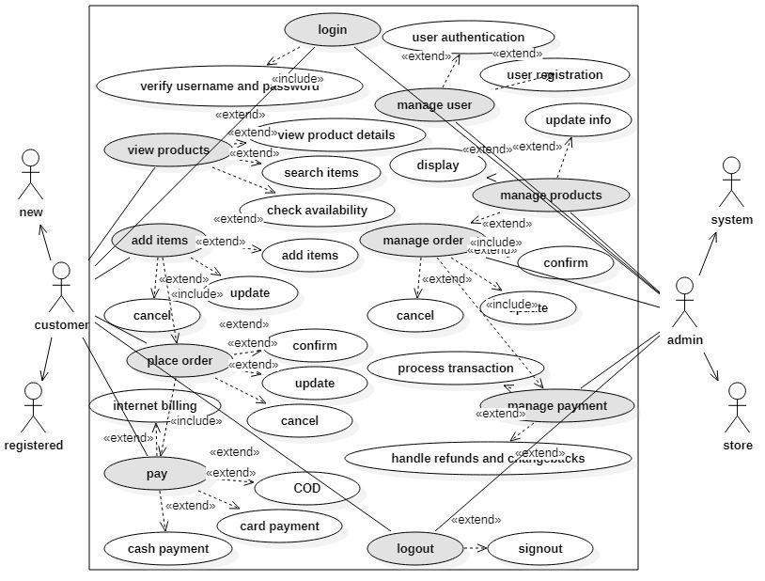



Chapter 7

Domain Model

## *7.1 Domain Model*

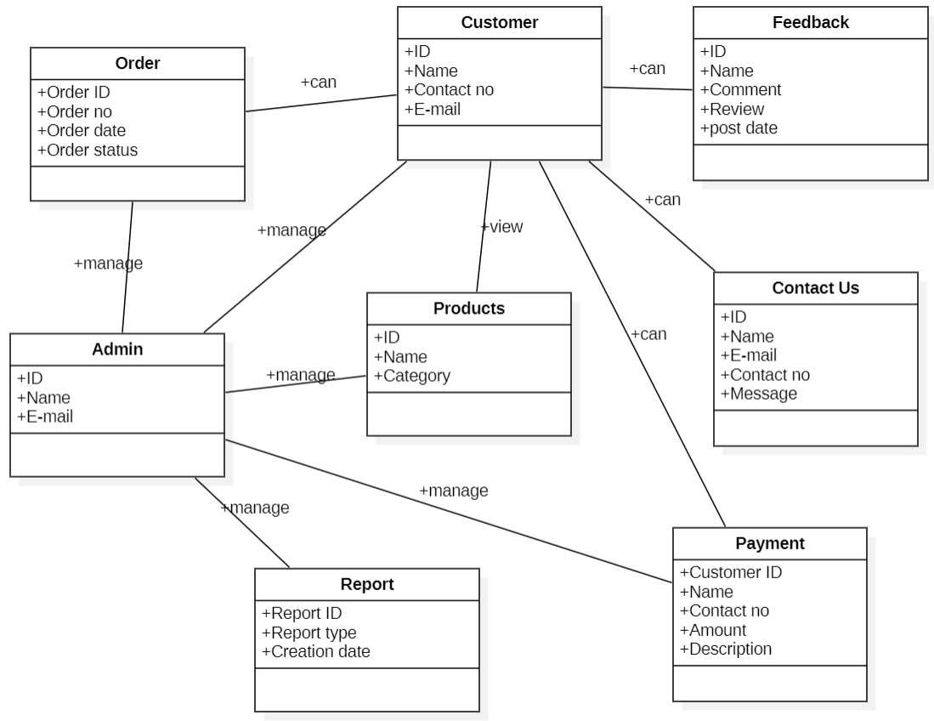

## 



Chapter 08

Sequence Diagram

## *8.1 Sequence Diagram*

### 8.1.1. SD 1: Login

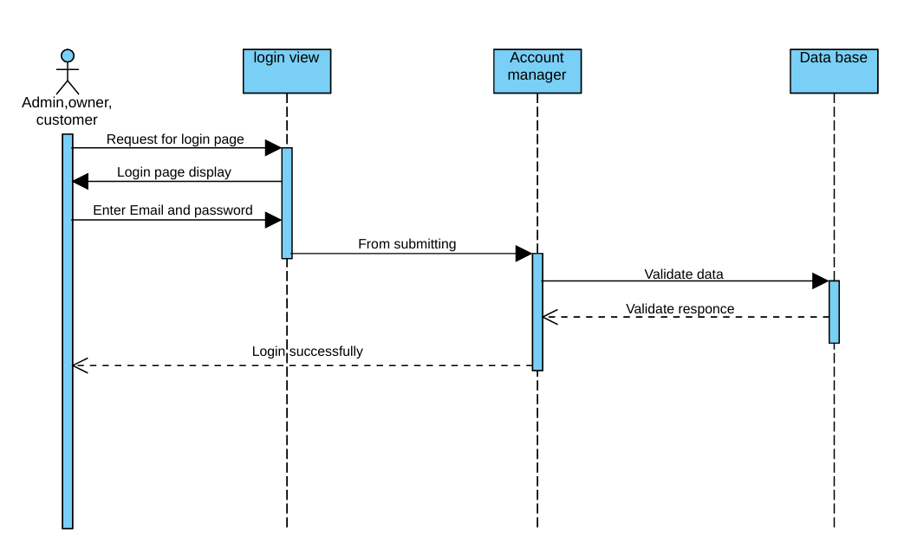

### 8.1.2. SD 2: Manage Products

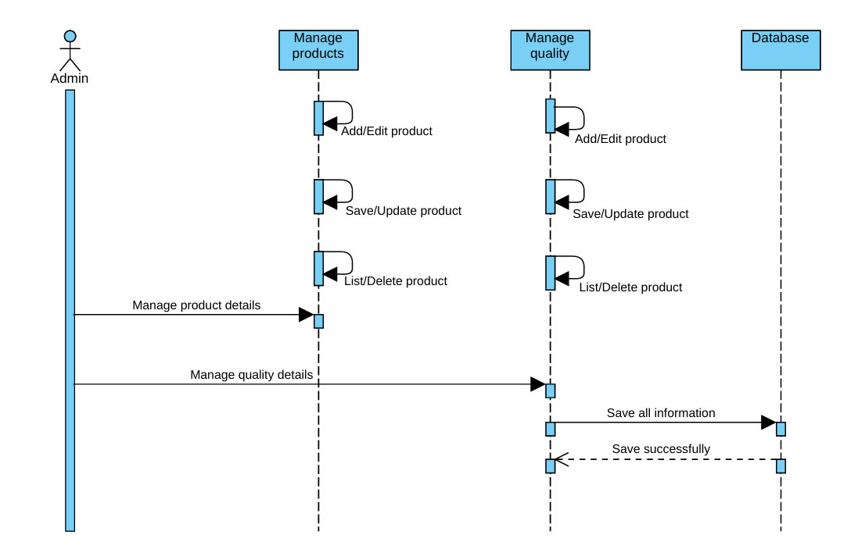

**8.1.3. SD 3: Manage Customers**

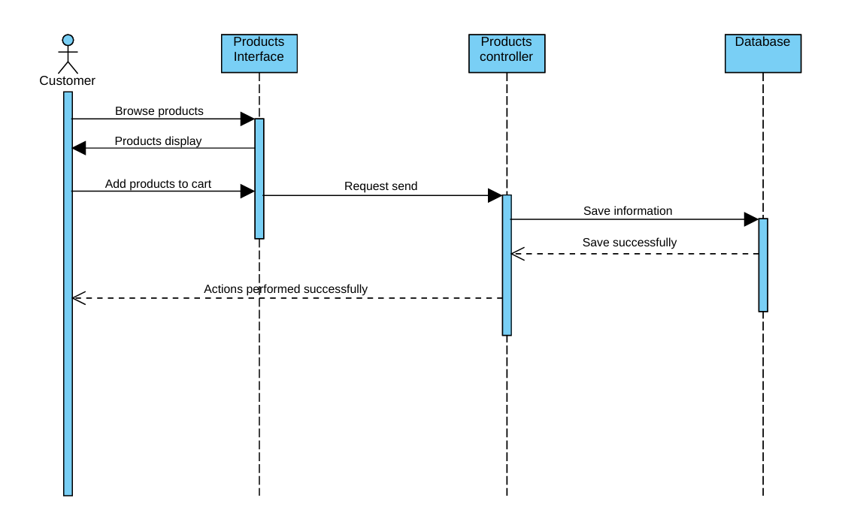

**8.1.4. SD 4: Place Order**

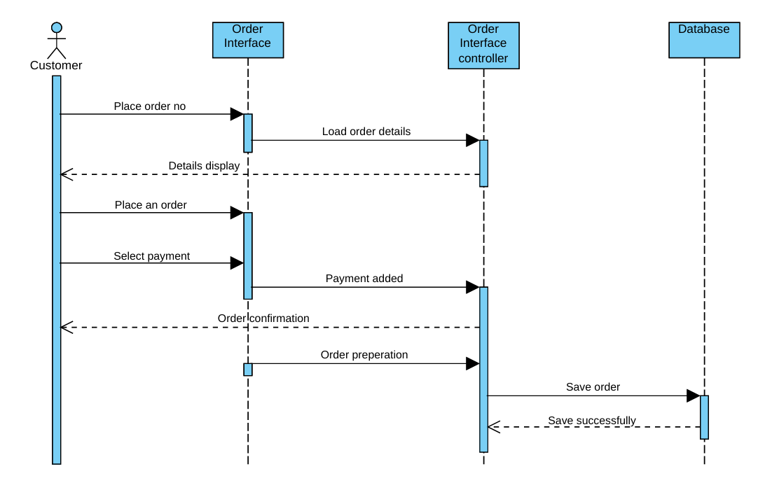

**8.1.5. SD 5: Make Payment**

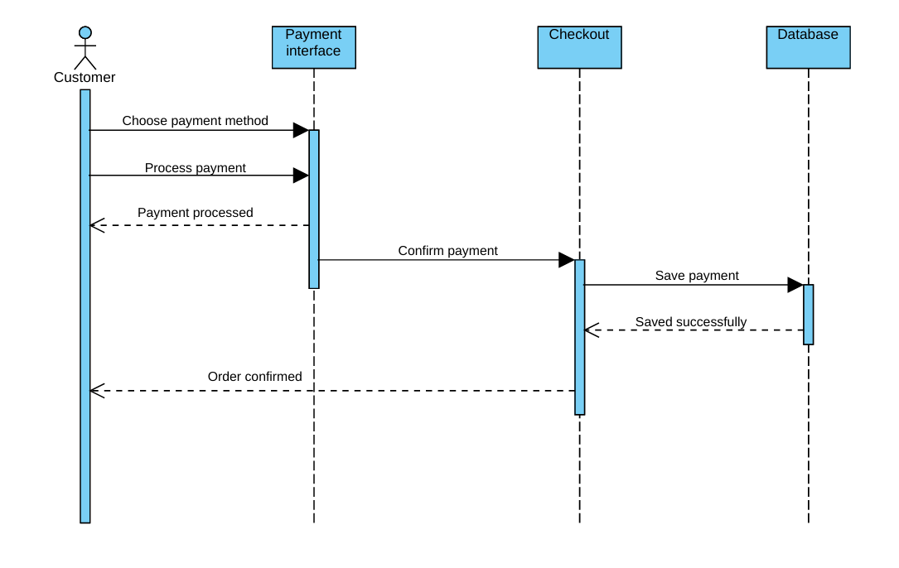

**8.1.6. SD 6: Feedback**

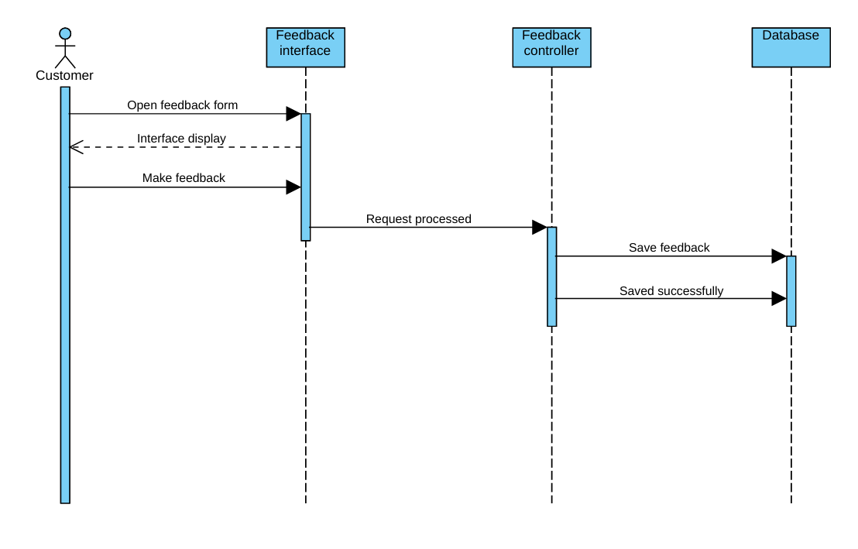

**8.1.7. SD 7: Logout**

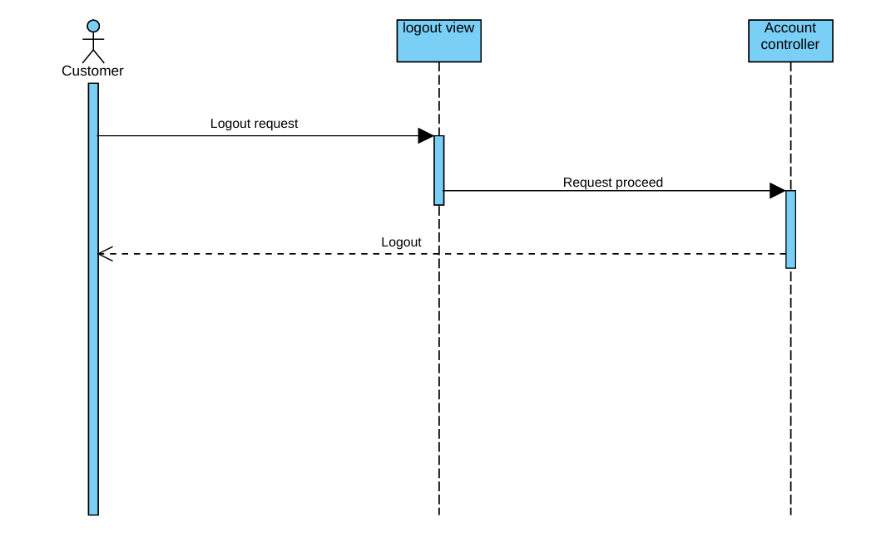

Chapter 09

Collaboration Diagram

# *9.1: Collaboration Diagrams*

**Use case UC_1:**

**UC_Registered:**

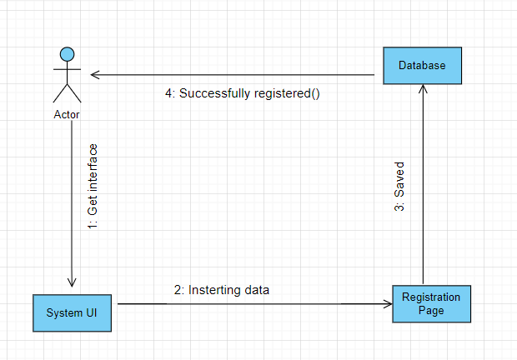

**Use case UC_2:**

**UC_Login:**

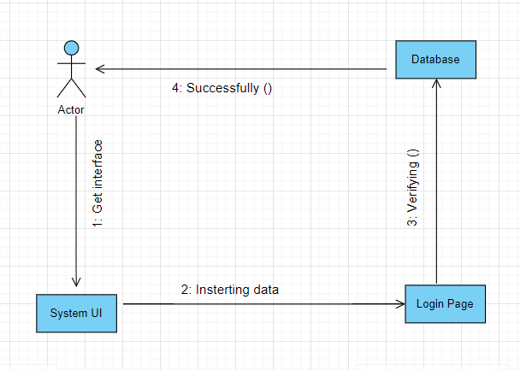

**Use case UC_3:**

**UC_Manager User:**

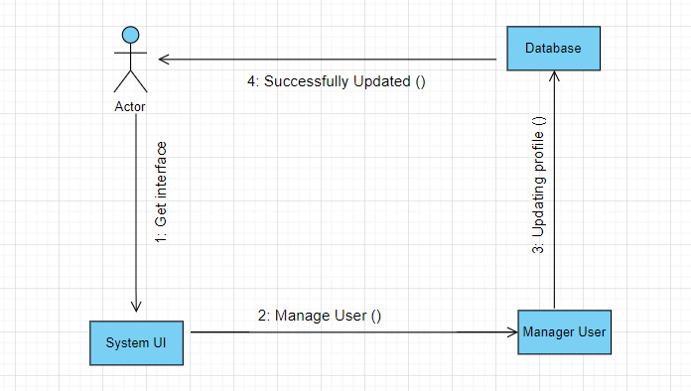

**Use Case UC_4:**

**UC_Generate Report:**

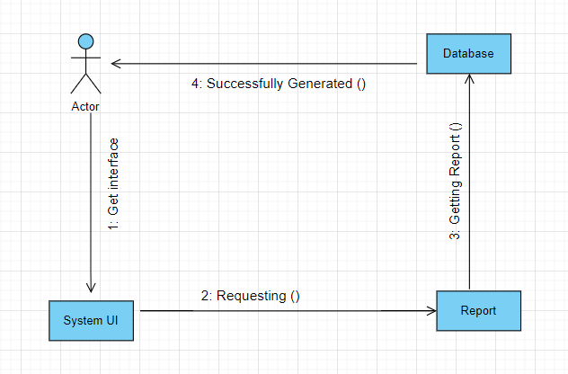

**Use Case UC_5:**

**UC_Manage Products:**

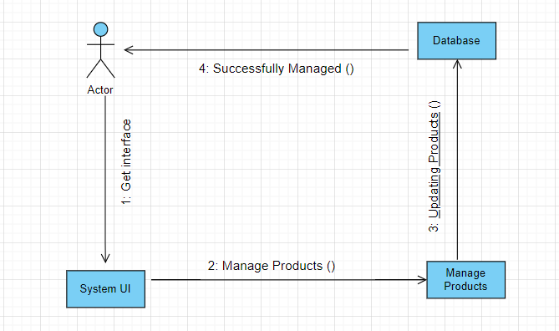

**Use Case UC_6:**

**UC_Manage Order:**

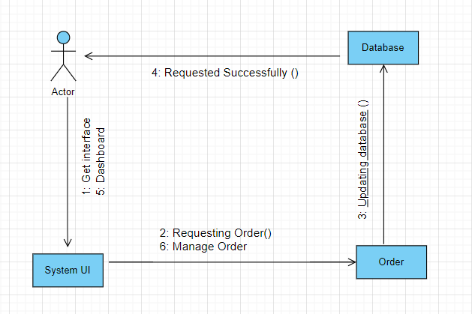

**Use Case UC_7:**

**UC _Payment Handling:**

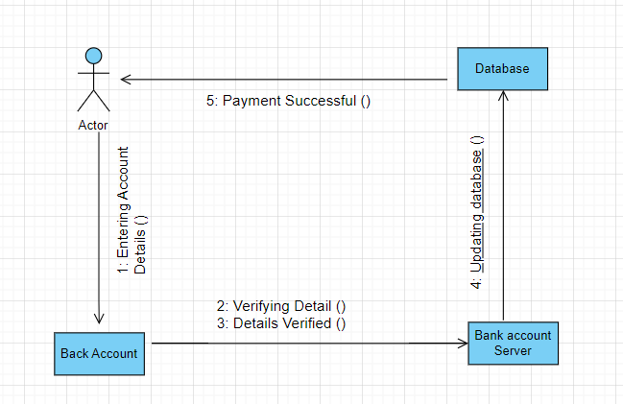

**Use Case UC_8:**

**UC_Posting Review:**

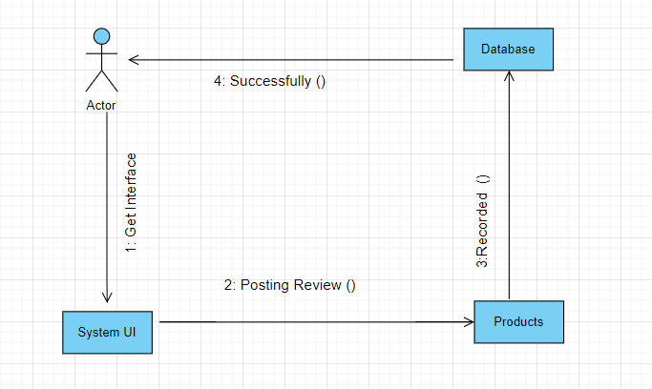

**Use Case UC_9:**

**UC_Logout:**

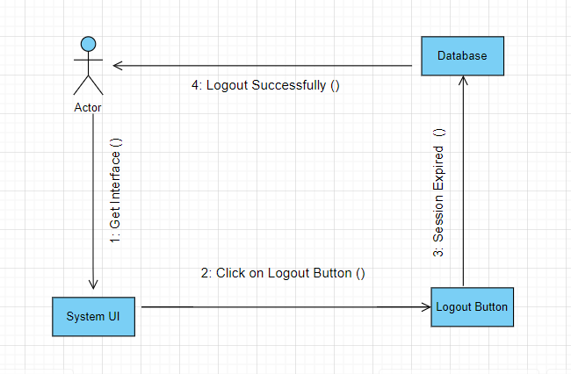

# 

Chapter 10

Operation Contract

# *10.1 Operation Contract*

Following are the operations and their contracts that we have used in our project.

### 10.6.1 Contract co1:

### UC_ Registration:

|  |  |
| --- | --- |
| **Operation** | Sign Up |
| **Responsibilities** | This use case allows the users to register themselves by creating their account. |
| **Cross Reference** | Use Case: UC_ Registration |
| **Exception** | The user is not registered if all necessary details are not provided. |
| **Pre-Conditions** | Users must have a proper interface to access and to provide required basic personal information to be registered to the website. |
| **Post-Conditions** | Users become registered members. |

### 10.6.2 Contract co2:

### UC_ Login:

|  |  |
| --- | --- |
| **Operation** | Login |
| **Responsibilities** | Granting Access to registered users to access the intended specialized interface and perform their required functionality. |
| **Cross Reference** | Use Case: UC_ Login |
| **Exception** | User is not registered. |
| **Pre-Conditions** | Registered User must be valid User of the system to access the services and requests to login to the system |
| **Post-Conditions** | Registered users can now use the services provided by the website successfully. |

### 10.6.3 Contract co3:

### UC_ Manage Product_info:

|  |  |
| --- | --- |
| **Operation** | Products |
| **Responsibilities** | To enable the Customer to check availability of Products. |
| **Cross Reference** | Use Case: UC_ Manage_product_info |
| **Exception** | Customers will be able to select a category of products for adding in to the cart. |
| **Pre-Conditions** | Customers should be valid users of the website. System must display the category of room. |
| **Post-Conditions** | Customer id details done successfully. |

### 10.6.4 Contract co4:

### UC_ Manage Order:

|  |  |
| --- | --- |
| **Operation** | Order |
| **Responsibilities** | To enable the Customer to order products. |
| **Cross Reference** | Use Case: UC_ Manage Order |
| **Exception** | Customers will be unable to order the products due to low balance. |
| **Pre-Conditions** | Customers should be valid users of the website. System must display the details of the Order. |
| **Post-Conditions** | Order is placed successfully. |

### 10.6.5 Contract co5:

### UC_ Manage Reports:

|  |  |
| --- | --- |
| **Operation** | Report |
| **Responsibilities** | To generate Reservation report of customer’s history. |
| **Cross Reference** | Use Case: UC_ Manage Reports |
| **Exception** | Admin is able to manage the reports properly. |
| **Pre-Conditions** | Admin must be logged in. |
| **Post-Conditions** | Proper reports are generated and viewed accordingly. |

### 

### 10.6.6 Contract co6:

### UC_ Payment Handling:

|  |  |
| --- | --- |
| **Operation** | Payment |
| **Responsibilities** | The admin handles the payment using some third-party services (PayPal). |
| **Cross Reference** | Use Case: UC_ Payment Handling |
| **Exception** | Admin will be unable to handle the payment if he is not logged in to the system and the customer does not have any product in the cart. |
| **Pre-Conditions** | Payment can only be handled by the admin. Customers should be users of the website. Must have some proper connection to interact with a back account. |
| **Post-Conditions** | Customers successfully do payment. |

## 

Chapter 11

Class Diagram

## *11.1Design Class Diagram:*

## 

Chapter 12

Data Model

## *12.1 Data Model*

